PROJECT-9:

Configuring IAM identities, MFA, and Access keys:

* IAM stands for Identity and Access Management, and it is a service provided by Amazon Web Services (AWS) that helps you manage access to your AWS resources.
* IAM allows you to control who can access your AWS resources (authentication) and what actions they can perform (authorization).
* With IAM, you can create and manage AWS users, groups, and roles.
* Each user is given a unique set of security credentials, such as a username and password or access keys, which are used to authenticate their identity when accessing AWS services.
* IAM enables you to create and manage individual IAM users within your AWS account.
* IAM allows you to organize your users into groups, making it easier to manage permissions and access for multiple users who have similar responsibilities.
* IAM supports MFA, which adds an extra layer of security by requiring users to provide an additional authentication factor, such as a one-time password generated by a hardware device or a virtual MFA app.
* IAM enables the creation and management of access keys (access key ID and secret access key) for programmatic access to AWS services using APIs or command-line interfaces.

STEPS:

1.Create 3 users user1, user2 and user3.

2. Create 3 user groups RDS-admin, S3-support, EC2-Support.

3.Assign RDS policy to group1,S3 policy to group2 and EC2 to group3.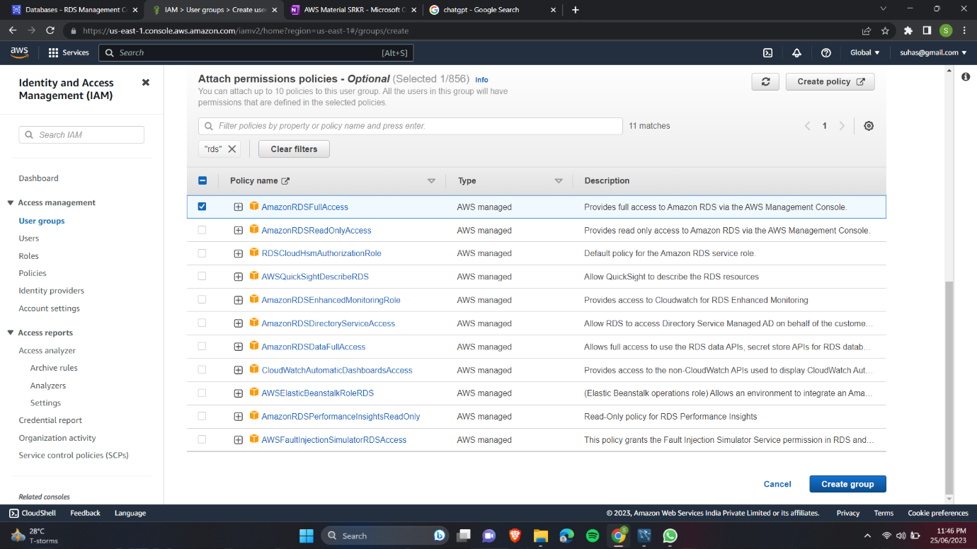

4.Add User1 under Group RDS-admin.

5. Add User2 under Group S3-Support.

6. Add User3 under Group EC2-support.

7. Login as User 1 and check if User 1 can launch an RDS database.

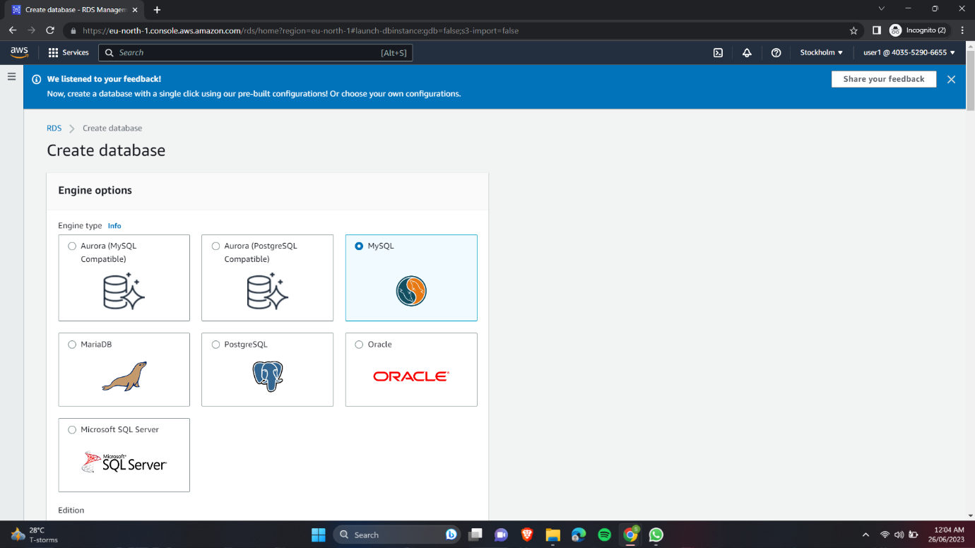

* we can create a database because it is having only RDS access.

8. Login as User2 and check if User2 can create an S3 bucket.

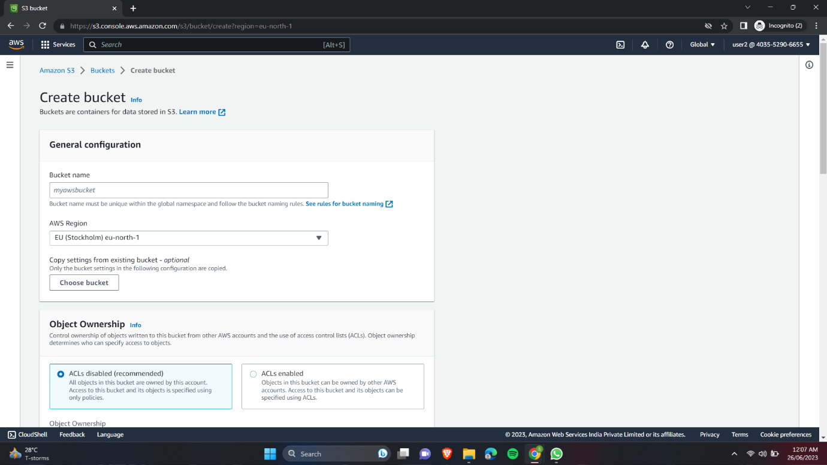

* we can create a S3 bucket and unable to create a database because it is having only S3 access.

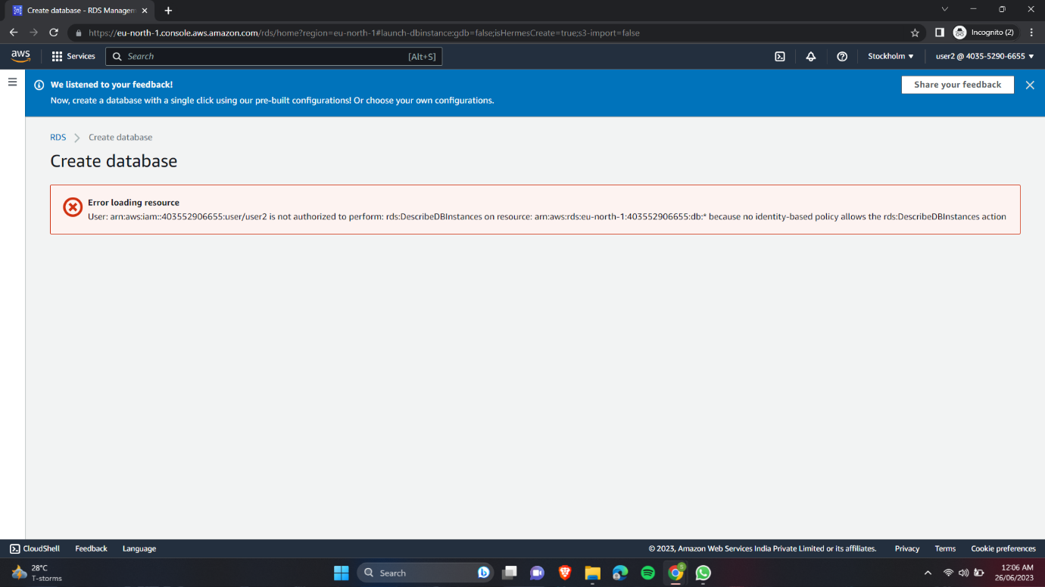

9. Login as User3 and check if User3 can launch an EC2 instance.

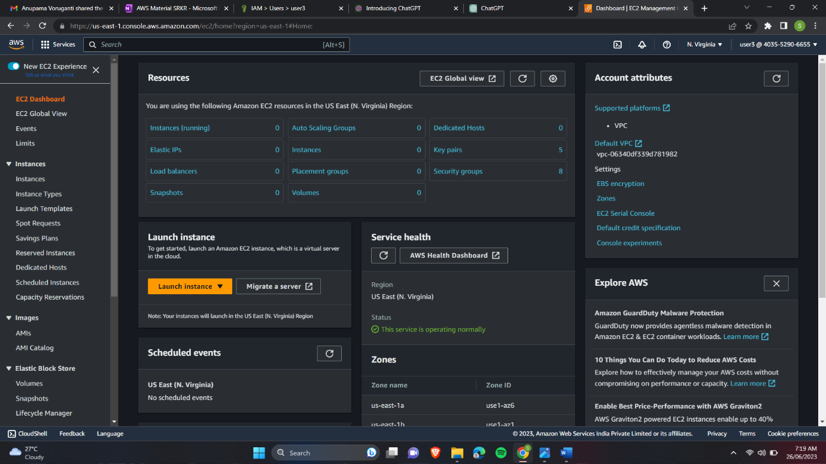

10.Go to Multi-Factor-Authentication and click on assign MFA device.

11.Provide device name and chose authenticator app option.

12.Scan the QR-Code in your authenticator app.

13.Provide with two MFA codes which you will see in your authenticator app.

14.Now sign out and try to login again.

15.After providing your credentials it will ask MFA code which will be in your authenticator app.

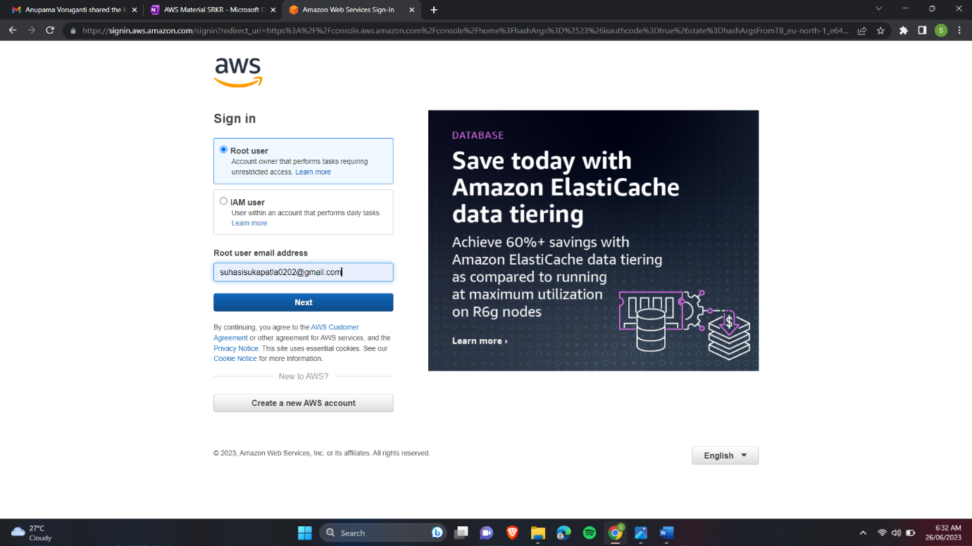

16.You will be successfully signed in.

